Below summarizes the ‘Stream Analytics’ settings for ingesting data from IoT devices onto SQL Database

**Input Settings (Assuming IoT Hub is setup)**

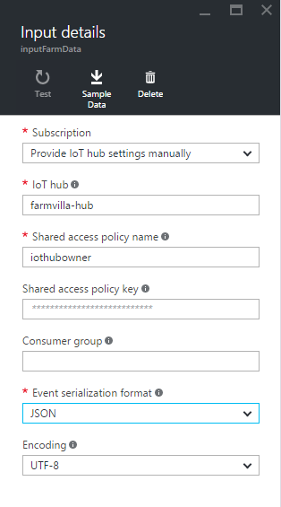

**The Query**

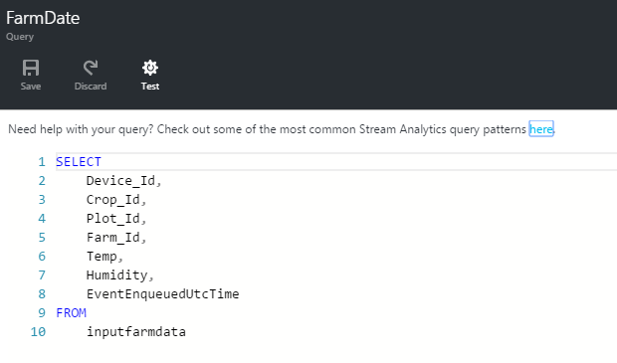

**Output to SQL Database (Assuming DB settings are in place)**

